Surviving debt, survival debt in times of lockdown[1]

Isabelle Guérina,b,c

Sébastien Michielsc,d

Arnaud Natale

Christophe Jalil Nordmana,c,f

Govindan Venkatasubramanianc

*a IRD (French National Research Institute for Sustainable Development), France*  
*b CESSMA (Social Science Center Studies in African, American and Asian Worlds; Université de Paris, IRD, Inalco), Paris, France*  
*c IFP (French Institute of Pondicherry), India*  
*d CNRS-CREST  
e University of Bordeaux, GREThA (UMR CNRS 5113), Bordeaux, France*

*f UMR LEDA-DIAL (Développement, Institutions, Mondialisation ; University Paris-Dauphine, IRD, CNRS, PSL), Paris, France*

contact author: Isabelle Guérin, isabelle.guerin@ird.fr

Abstract

What are the consequences of the Indian lockdown in terms of household debt? Drawing on quantitative and qualitative data collected in rural Tamil Nadu, this paper highlights massive risks of financial fragility. Our quantitative data show a very high level of pre-covid debt, which rose sharply during the decade 2000. The lockdown was accompanied by a large-scale suspension of repayments. This concerns both formal debts, following the moratorium imposed by the Central Bank, and some informal debts, which still account for a very large share of household debt. At the same time, we also observe a halt to unsecured debt and an erosion of the trust that cements most transactions. Last, and not least, we observe the emergence of new forms of secured debt that seriously threaten household assets. The sharp rise in debt observed over the last decade is the result of a widening of credit opportunities. These have been made possible by building new relationships of trust but also of confidence in the future, based on strong economic growth that was believed to be sustainable. The lockdown highlights the fragility of these dynamics.

Keywords: Covid-19, Debt, lockdown, caste, labour, India, trust

Introduction

The lockdown has brought to light a crucial component of the Indian economy: its migrant and circulating workforce (Breman 2020; Srivastava 2020). Another aspect of the Indian economy, largely underestimated and whose consequences are nevertheless essential, concerns household indebtedness. As in other emerging countries, economic growth in India over the last two decades has been built on a sharp increase in household debt. Apart from farmers, the rise in household debt in India has never been a real source of concern. This is true both among decision-makers, academics or activists, probably because official statistics significantly underestimate the amount of household debt, and because until now, growth prospects have suggested good repayment capacities. The current crisis reveals the fragility of household debt.

The rise in household debt, in India and other parts of Southern countries, is the outcome of several factors (Servet and Saiag 2013; UN 2020). Low and irregular real incomes are one such factor, given the persistence of informal and vulnerable employment (Harriss-White 2020). In various sectors, debt, in the form of a wage advance, is a method of regulating the workforce and acts as a kind of contract (Breman 2007; Guérin 2013). Expenses are meanwhile increasing. Self-consumption, long a pillar of food security for rural families, has declined sharply over the last decades. Access to basic services such as water, electricity, housing and healthcare are becoming increasingly commodified (Greene and Morvant-Roux 2020). There has been an explosion of private provision of education, including among poor households seeking a better future for their children. The depletion of certain natural resources and of hitherto free common goods (drying up of groundwater, the disappearance of forest areas or restricted access to them, etc.) is causing substantial loss of earnings or additional expenses. The adoption of urban lifestyles has led to a considerable increase in the supply of new goods, both identity and functional in nature. This is the case of mobile phones, but also of household appliances, computers, internet access, motor vehicles (motorcycles or cars).

At the same time, the combination of strong economic growth and growing inequality (Shah et al. 2018; Chancel and Piketty 2019), which is typical of the Indian economy but also of many emerging countries, is fueling strong aspirations for social mobility. These can translate into the acquisition of sustainable consumer goods, a sign of integration into the consumer society. Aspirations can also translate into social investments such as marriage alliances, as in South Africa or India (James 2015; Srinivasan 2005).

For households that are already massively indebted, and at a time when their sources of income are negatively affected, what have been the consequences of the first lockdown? In some countries, regulatory moratoriums force credit providers to suspend repayments. This has been the case in India until end of August 2020, and this was obviously very good news for borrowers, at least in the short term. But has the moratorium been respected? What about informal lenders, who still represent the bulk of debt sources? And in order to survive the day-to-day, did households have the possibility of taking on new debts to cope with their falling income? In the absence of income, were they forced to mortgage assets and what will be the consequences? The drop in income is obviously dramatic in the short term. The loss of assets is even more dramatic because it threatens future security, and the scale of a crisis can be measured precisely by the size of the assets destroyed. In addition to physical capital (land, housing, agricultural equipment, and, in India, gold), reputation and trust play a crucial role since both largely condition creditworthiness (and access to employment). The embeddedness of economic transactions in personal relationships, typical of informal economies (Platteau 1994; Hart 2000), remains a predominant reality in India (Harriss-White 2003).

This article is an attempt to answer these questions. It is based on a case study located in a rural area of east-central Tamil Nadu, combining pre-covid longitudinal data and qualitative interviews conducted during the first lockdown. The financial landscape of this region has been profoundly transformed in recent decades, and these transformations are inseparable from deep agrarian, economic and social transformations: the decline of agriculture, access to non-agricultural employment outside the village, a relative and fragile emancipation of Dalits from upper castes, both in terms of labour and debt, and a strengthening of Dalit solidarity, including regarding access to debt. The sharp rise in debt is the result of a widening of credit opportunities, partly formal but mostly informal. These have been made possible by building new relationships of trust but also of confidence in the future, based on strong economic growth that was believed to be sustainable. The lockdown highlights the fragility of these dynamics.

1. Data and context

Our findings rely on an original socio-economic survey conducted in a rural area located in coastal/central Tamil Nadu, at the border between Villuppuram and Cuddalore districts. We used pre-pandemic quantitative data, which set the context, combined with qualitative data collected by telephone during the first lockdown.

Quantitative data include longitudinal data collected at the household and individual levels, first in 2010 (RUME) and then in 2016-17 (NEEMSIS), and which focus primarily on labour arrangements (including migration), financial practices (debt and saving), consumption, remittances and social networks[2]. 2,692 individuals from 492 households were surveyed. The original households and villages were randomly selected in 2010 from a sample stratified by caste, ecotypes system and proximity to neighbouring cities and constituted then the sampling frame for collecting a panel dataset in 2016-17 (a second wave of NEEMSIS was underway in 2020-21 but was not used in this article; for first results, see Guérin, Mouchel, Nordman 2021).

Data collection took place within two broader research programmes located within the Observatory of Rural Dynamics and Inequalities at the French Institute of Pondicherry[3]. In addition to quantitative surveys, various qualitative tools have been used since 2003 and include semi-structured interviews, life histories and financial diaries. This long-term presence in the same field has enabled us to build special relationships with villagers, from landowners and local politicians to daily labourers, both men and women. At the time the first lockdown was announced in May 2020, many villagers contacted us by phone to obtain information about the duration of the lockdown, government programmes, sales opportunities for farmers’ products, etc. We took advantage of these spontaneous requests to ask them about their perception and their copying tactics and strategies. We also helped set up a food distribution system, a measure that we felt was ethically indispensable given our long-term commitment to the region. We then conducted about thirty semi-directive interviews around the issues of employment, savings, debt and food security with people from different backgrounds in terms of occupation, class, caste and gender. Our qualitative analysis combines our previous knowledge of the region with these telephone interviews.

The original studied zone is economically dynamic, featuring a large proportion of irrigated agriculture, two industrial towns (Neyveli and Cuddalore) and a regional business centre (Panruti). Vanniyars and Paraiyars are the two major local groups across the region. Vanniyars can be qualified as “middle castes”. They are a farming caste with a low ritual rank, but in the villages we studied, as in many places in northeast Tamil Nadu, they control much of the land and are politically dominant[4]. Paraiyars are one of the major Dalit communities in Tamil Nadu. There are also few Arunthathiyars among the Dalits in the studied zone. The upper castes of the local hierarchy are the Mudaliyars, Chettiyars, Naidus, Reddiyars, Settus and Yathavars, who account for a small proportion of the village population only. Christians and Muslims are a minority in the area. Lower castes or Dalits represent 48.0 percent of households, middle castes 40.4 percent and upper castes 11.6 percent of households of the NEEMSIS sample.

The region has seen many changes over the last three decades. Upper castes have mostly moved away from the villages to nearby towns, adopting urban jobs and lifestyles, and selling an important part of their land to Vanniyars. Overall, upper castes still have a hold on village life but are not as powerful as they used to be (Harriss 2013). Land transfers to Vanniyars explain in great part why they are now dominant (Harriss and Jeyaranjan 2016), given that their dominance is permanently contested, including by Dalits (Pandian 2000). As for Dalits, although their situation has been improving thanks to the combination of short term migration to nearby towns and industrial centres (Michiels, Nordman and Seetahul 2021), and governmental schemes (reflected by subsidized housing, food, education, etc.; Guérin, Venkatasubramanian, and Michiels 2014)[5], inequalities persist, whether in terms of education, income or assets (see Table 1).

Table 1 Characteristics of the population – Source: RUME (2010) and NEEMSIS-1 (2016-17); author’s calculations.

|  |  |  |  |  |  |  |  |  |  |  |  |
| --- | --- | --- | --- | --- | --- | --- | --- | --- | --- | --- | --- |
|  | Dalits | |  | Middle | |  | Upper | |  | Total | |
|  | 2010 | 2016-17 |  | 2010 | 2016-17 |  | 2010 | 2016-17 |  | 2010 | 2016-17 |
| Number of households | n=194 | n=236 |  | n=158 | n=199 |  | n=53 | n=57 |  | n=405 | n=492 |
| **Households characteristics** |  |  |  |  |  |  |  |  |  |  |  |
| Household size (mean) | 4.6 | 4.9 |  | 4.7 | 4.6 |  | 4.3 | 4.0 |  | 4.6 | 4.7 |
| House type (%) |  |  |  |  |  |  |  |  |  |  |  |
| *Concrete house* | 54.6 | 39.8 |  | 72.8 | 57.8 |  | 84.9 | 75.4 |  | 65.7 | 51.2 |
| *Government/green house* | 17.5 | 26.7 |  | 0.6 | 10.0 |  | 1.9 | 10.5 |  | 8.9 | 18.1 |
| *Thatched roof house* | 27.8 | 33.5 |  | 26.6 | 32.2 |  | 13.2 | 14.0 |  | 25.4 | 30.7 |
| Land owner (%) | 41.7 | 19.9 |  | 70.9 | 44.2 |  | 50.9 | 28.1 |  | 54.3 | 30.7 |
| Size own land (acre) |  |  |  |  |  |  |  |  |  |  |  |
| *Mean* | 1.4 | 1.5 |  | 2.1 | 2.6 |  | 3.4 | 4.6 |  | 2.0 | 2.5 |
| *SD* | 1.0 | 1.9 |  | 1.6 | 2.7 |  | 2.7 | 4.0 |  | 1.7 | 2.8 |
| *Median* | 1.0 | 1.0 |  | 2.0 | 2.0 |  | 2.0 | 4.8 |  | 1.5 | 1.0 |
| Nber income source (mean) | 3.6 | 4.7 |  | 3.1 | 4.1 |  | 2.8 | 3.1 |  | 3.3 | 4.3 |
| Share of non-agri income* | 57.4 | 67.1 |  | 51.9 | 64.9 |  | 73.2 | 80.6 |  | 57.3 | 68.0 |
| Annual income (1,000 INR) |  |  |  |  |  |  |  |  |  |  |  |
| *Mean* | 78.7 | 111.9 |  | 80.0 | 118.5 |  | 94.6 | 117.3 |  | 81.3 | 115.2 |
| *SD* | 54.7 | 210.9 |  | 48.3 | 137.5 |  | 100.1 | 85.9 |  | 60.4 | 172.5 |
| *Median* | 66.0 | 67.7 |  | 70.0 | 82.1 |  | 80.0 | 102.6 |  | 68.0 | 77.3 |
| Assets (1,000 INR) |  |  |  |  |  |  |  |  |  |  |  |
| *Mean* | 770.0 | 351.7 |  | 1,684.7 | 1,098.3 |  | 2,047.3 | 1,267.9 |  | 1,294.0 | 760.0 |
| *SD* | 945.0 | 675.0 |  | 1,613.7 | 1,866.8 |  | 2,728.2 | 2,002.4 |  | 1,631.8 | 1,495.7 |
| *Median* | 241.0 | 171.9 |  | 1,267.2 | 434.7 |  | 717.0 | 452.3 |  | 701.0 | 258.8 |
| Assets without land (1,000 INR) |  |  |  |  |  |  |  |  |  |  |  |
| *Mean* | 196.1 | 176.9 |  | 265.2 | 362.7 |  | 320.8 | 452.5 |  | 239.4 | 284.0 |
| *SD* | 108.3 | 148.3 |  | 150.1 | 559.2 |  | 162.2 | 382.7 |  | 140.6 | 405.8 |
| *Median* | 179.0 | 147.2 |  | 236.5 | 230.1 |  | 302.0 | 397.5 |  | 195.5 | 183.0 |
| **Household head characteristics** |  |  |  |  |  |  |  |  |  |  |  |
| Male (%) | 91.2 | 89.66 |  | 94.30 | 93.40 |  | 98.11 | 96.49 |  | 93.33 | 91.98 |
| Age (mean) | 46.7 | 50.38 |  | 48.16 | 52.01 |  | 51.77 | 55.67 |  | 47.94 | 51.66 |
| Education (%) |  |  |  |  |  |  |  |  |  |  |  |
| *Below primary* | 55.1 | 57.8 |  | 41.8 | 37.6 |  | 35.8 | 22.8 |  | 47.4 | 45.5 |
| *Primary completed* | 19.1 | 17.7 |  | 18.3 | 26.9 |  | 22.6 | 26.3 |  | 19.3 | 22.4 |
| *High school* | 22.2 | 19.4 |  | 36.7 | 28.4 |  | 39.6 | 36.8 |  | 30.1 | 25.1 |
| *HSC/Diploma* | 2.6 | 4.3 |  | 2.5 | 5.6 |  | 0.0 | 12.3 |  | 2.2 | 5.8 |
| *Bachelors* | 0.5 | 0.4 |  | 0.0 | 1.0 |  | 1.9 | 1.7 |  | 0.5 | 0.8 |
| *Post graduate* | 0.5 | 0.4 |  | 0.6 | 0.5 |  | 0.0 | 0.0 |  | 0.5 | 0.4 |
| Note: *Share of non-agricultural activity in the total income of the household. | | | | | | | | | | | |

Like elsewhere in India, non-farm income is now largely dominant across all social categories and its share continues to grow. In 2016-17, 68 percent of total household income comes from non-farm activities, compared to 57% in 2010. The first impact of the lockdown is, of course, the fall in non-farm income: with a few exceptions (permanent jobs, but not all), off-farm income has come to an abrupt halt, and migrants may even continue to have to pay their urban rent. Clearly, agriculture is the most resilient, but this is especially true for subsistence crops and in irrigated areas. For cash crops (here, sugar cane, casuarina and tapioca), distribution networks have been severely disrupted. As for the NREGA, which usually plays an important role as an income supplement for women (regardless of their level of poverty and caste), it is being transformed. Non-existent for the first two months of the lockdown, even though the needs were immense, it slowly began to recover in May 2020, targeting both men and women and providing precious liquidity. In-kind food aid through PDS shops, which has always worked quite well in this region, has played and still plays an essential role in food security.

What about liquid saving? In spite of a massive democratisation of bank accounts – almost all households have at least one – most savings accounts remain empty and are only used to channel social benefits. As shown elsewhere, it is more rational to save with gold, which acts like a quasi-money (Goedecke et al. 2018), and with investments "in people", whether these are ceremonial gifts or loans to others (Guérin, Venkatasubramanian, and Kumar 2020). Monetary savings are therefore limited. It is not completely absent, and families who had cash saving when the lockdown was announced were obviously in a much better position than others, but many families have almost none. The amount of debt, on the other hand, is high.

1. The burden of debt

In our 2016-17 survey, almost all households are indebted (99 percent) and most often have several loans, taken out by different people within the household. The median number of loans per person is two, for a total of 4 loans per family on average (sometimes up to more than 10 loans). Loans vary greatly in amount (between INR 650 to INR 645,000) with an average of INR 38,000 (median at 19,000). The average debt per family is INR 243,000, which represents on average almost three times their annual income (median at 130 percent).

It is a known fact that debt, and its flip side, credit, is a double-edged sword. The effects of debt depend upon the way it is used – investing or consuming, the real cost, and the hazards that borrowers may face. Debt may protect debtors and allow them to smooth their income. It may enable them to seize opportunities – digging or improving a well, acquiring a motorcycle taxi, setting up a small grocery store, renovating a house, investing for the future of children, either in education or marriage. But if the investment goes wrong, if the return on investment is less than the cost of the loan, or is obtained too late, if the debt is only used to make ends meet, then debt can be a source of impoverishment.

Our longitudinal data over the spell 2010 to 2016-17 are instructive here. Debt has exploded over the period: median amounts have increased by a factor of 1.5, and more importantly, they have grown much faster than incomes and wealth. For households in the first asset tercile, and for Dalits, the debt/asset ratio is of particular concern (see Figure 1 and Figure 2). For both groups, the distribution is much more spread out to the right, reflecting worrying levels of financial fragility. The debt service – the share of their income that households spend for debt repayment – is also revealing: the average amount is 48 percent, and the median amount is 22 percent.

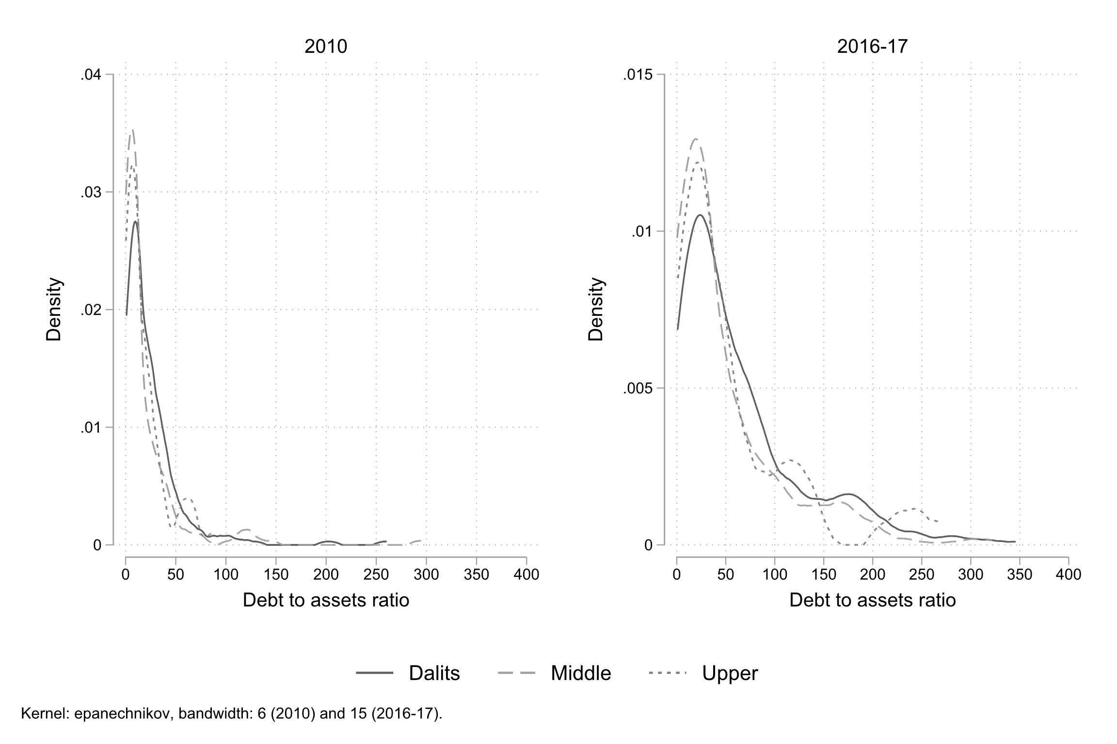

Figure 1: Kernel density of Debt to Assets Ratio by castes -- **Source**: RUME (2010) and NEEMSIS-1 (2016-17); author’s calculations

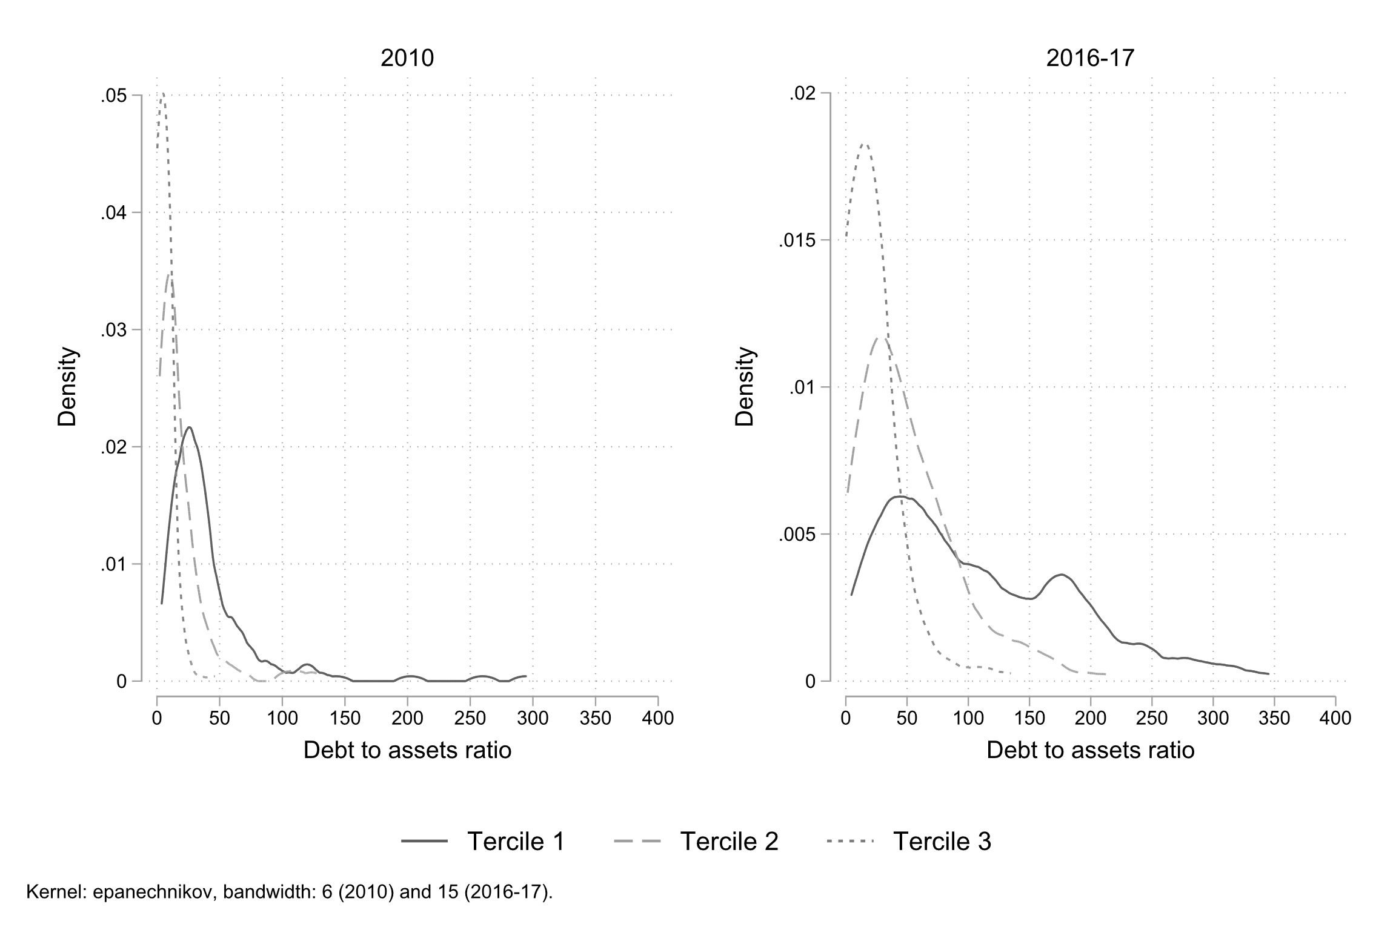

Figure 2: Kernel density of Debt to Assets Ratio by tercile of assets -- **Source**: RUME (2010) and NEEMSIS-1 (2016-17); author’s calculations

In line with the decline of farming, it is also observed that the share of debt for economic investment is declining (from 32.7 to 26.4 percent in volume between 2010 and 2016-17, see table 2). The share of debt for current expenses and human capital have decreased, while remaining non negligible: in 2016-17, debts are partly used to make ends meet (32 percent of the loans are used for current expenses, 16.7 percent in volume). But the share of ceremonial and housing expenses is increasing. In a context in which finding a job depends on social relationships and not just on a school degree, marriages are considered as key tools for social mobility or at least security, especially for daughters (De Neve 2016). With strong economic growth for several decades, along with democratisation (with the growing importance of Dalit political movements), and rising inequalities (Chancel and Piketty 2019), households have aspirations. If disposable incomes do not increase, or unless people adopt an “ascetic morality”, they experience subjective impoverishment (Servet and Saiag 2013, p. 33). Aspirations often exceed income: debt is thus used to fill the gap. In India, not only is growth slowing down, but it may have been overestimated (Subramanian 2019)[6], creating illusions of growth and risky bets on the future.

Table 2 Purpose of loans -- Source: RUME (2010) and NEEMSIS-1 (2016-17); author's calculations.

|  |  |  |  |  |  |  |  |  |  |  |  |  |
| --- | --- | --- | --- | --- | --- | --- | --- | --- | --- | --- | --- | --- |
|  |  | % of loans | |  | % of HH using it | |  | Mean (1,000 INR) | |  | % in the total volume of loans | |
|  |  | 2010 | 2016 |  | 2010 | 2016 |  | 2010 | 2016 |  | 2010 | 2016 |
| Economic investment |  | 24.4 | 14.1 |  | 56.5 | 30.4 |  | 28.5 | 70.5 |  | 32.7 | 26.4 |
| *Agriculture* |  | *19.4* | *8.9* |  | *47.9* | *18.5* |  | *25.3* | *62.7* |  | *23.1* | *14.9* |
| *Investment* |  | *5.0* | *5.2* |  | *14.8* | *14.0* |  | *41.0* | *83.8* |  | *9.6* | *11.5* |
| Current expenses |  | 36.7 | 32.0 |  | 80.5 | 65.3 |  | 11.7 | 19.5 |  | 20.0 | 16.7 |
| *Family* |  | *27.0* | *26.7* |  | *73.3* | *57.5* |  | *10.7* | *18.4* |  | *13.5* | *13.1* |
| *Repay previous loan* |  | *4.5* | *4.7* |  | *18.5* | *16.4* |  | *18.8* | *27.7* |  | *3.9* | *3.4* |
| *Relatives* |  | *5.2* | *0.6* |  | *23.7* | *2.0* |  | *10.7* | *11.7* |  | *2.6* | *0.2* |
| Human capital |  | 17.9 | 15.9 |  | 53.3 | 37.8 |  | 24.2 | 29.2 |  | 20.4 | 12.4 |
| *Health* |  | *10.3* | *7.7* |  | *35.1* | *20.1* |  | *27.1* | *26.7* |  | *13.2* | *5.5* |
| *Education* |  | *7.6* | *8.2* |  | *26.7* | *21.8* |  | *20.2* | *31.6* |  | *7.2* | *6.9* |
| Social and ritual events |  | 11.4 | 23.2 |  | 39.5 | 44.8 |  | 25.5 | 42.8 |  | 13.7 | 26.3 |
| *Ceremonies* |  | *3.5* | *6.3* |  | *15.6* | *20.5* |  | *13.0* | *21.2* |  | *2.2* | *3.5* |
| *Marriage* |  | *7.0* | *15.6* |  | *22.7* | *26.7* |  | *33.2* | *53.7* |  | *10.9* | *22.3* |
| *Death* |  | *0.9* | *1.3* |  | *3.7* | *4.5* |  | *14.4* | *14.6* |  | *0.6* | *0.5* |
| Housing |  | 9.6 | 13.3 |  | 29.4 | 28.1 |  | 29.1 | 39.6 |  | 13.1 | 14.1 |
| Other |  | 0.0 | 1.5 |  | 0.0 | 4.9 |  | 29.1 | 99.5 |  | 0.0 | 3.9 |
| *No reason* |  | *0.0* | *0.2* |  | *0.0* | *0.6* |  | *0.0* | *51.8* |  | *0.0* | *0.2* |
| *Other* |  | *0.0* | *1.3* |  | *0.0* | *4.3* |  | *0.0* | *104.8* |  | *0.0* | *3.7* |
|  |  |  |  |  |  |  |  |  |  |  |  |  |
| Total |  | 100.0 | 100.0 |  | 405 HH | 487 HH |  | 21.3 | 37.5 |  | 100.0 | 100.0 |

1. The financial landscape: informal and segmented

Over the last two decades, active financial inclusion policies have been implemented, combining the provision of credit, initially by NGOs and increasingly by private microfinance organisations, and the opening of bank accounts (Nair 2016; Kar 2018). Despite these massive efforts, formal finance, regulated by the state and based on written contracts, accounts for only 29 percent of the amounts borrowed at the household level in terms of volume (2016-17). Formal finance includes ‘finance’ (local term for microfinance companies) and banks. Finance targets exclusively women. Dalits and casual daily labourers are also over-represented. Banks are restricted to men, landowners and farmers.

At the household level, more than two-thirds of the loan volume therefore continues to come from informal or semi-formal sources. Among the informal sources, “well-known persons” (WKP) – the term locally used – are the most important sources in terms of number of loans, users and volume (almost a third of loan volumes, and 70 percent of users in 2016-17, see figures 3 and 4). This category includes a wide range of profiles: a few castes specialised in lending, but above all, a wide range of people for whom lending is not a profession and who have surplus cash to invest, mostly landowners, local entrepreneurs and wage earners. The figure of the “moneylender”, which is often used to describe rural usury, does not really exist, as is also observed in other parts of India (Gregory 1997). Next come the relatives, then employers and labour recruiters (“labour” category). The latter are over-represented among Dalits and landless (see table 3) and take the form of wage advances, which are repaid through labour and often entail freedom restrictions. Pawnbrokers are another fundamental source, especially for women. We qualify them as semi-formal because many operate without a license while still lending on the basis of a written contract.

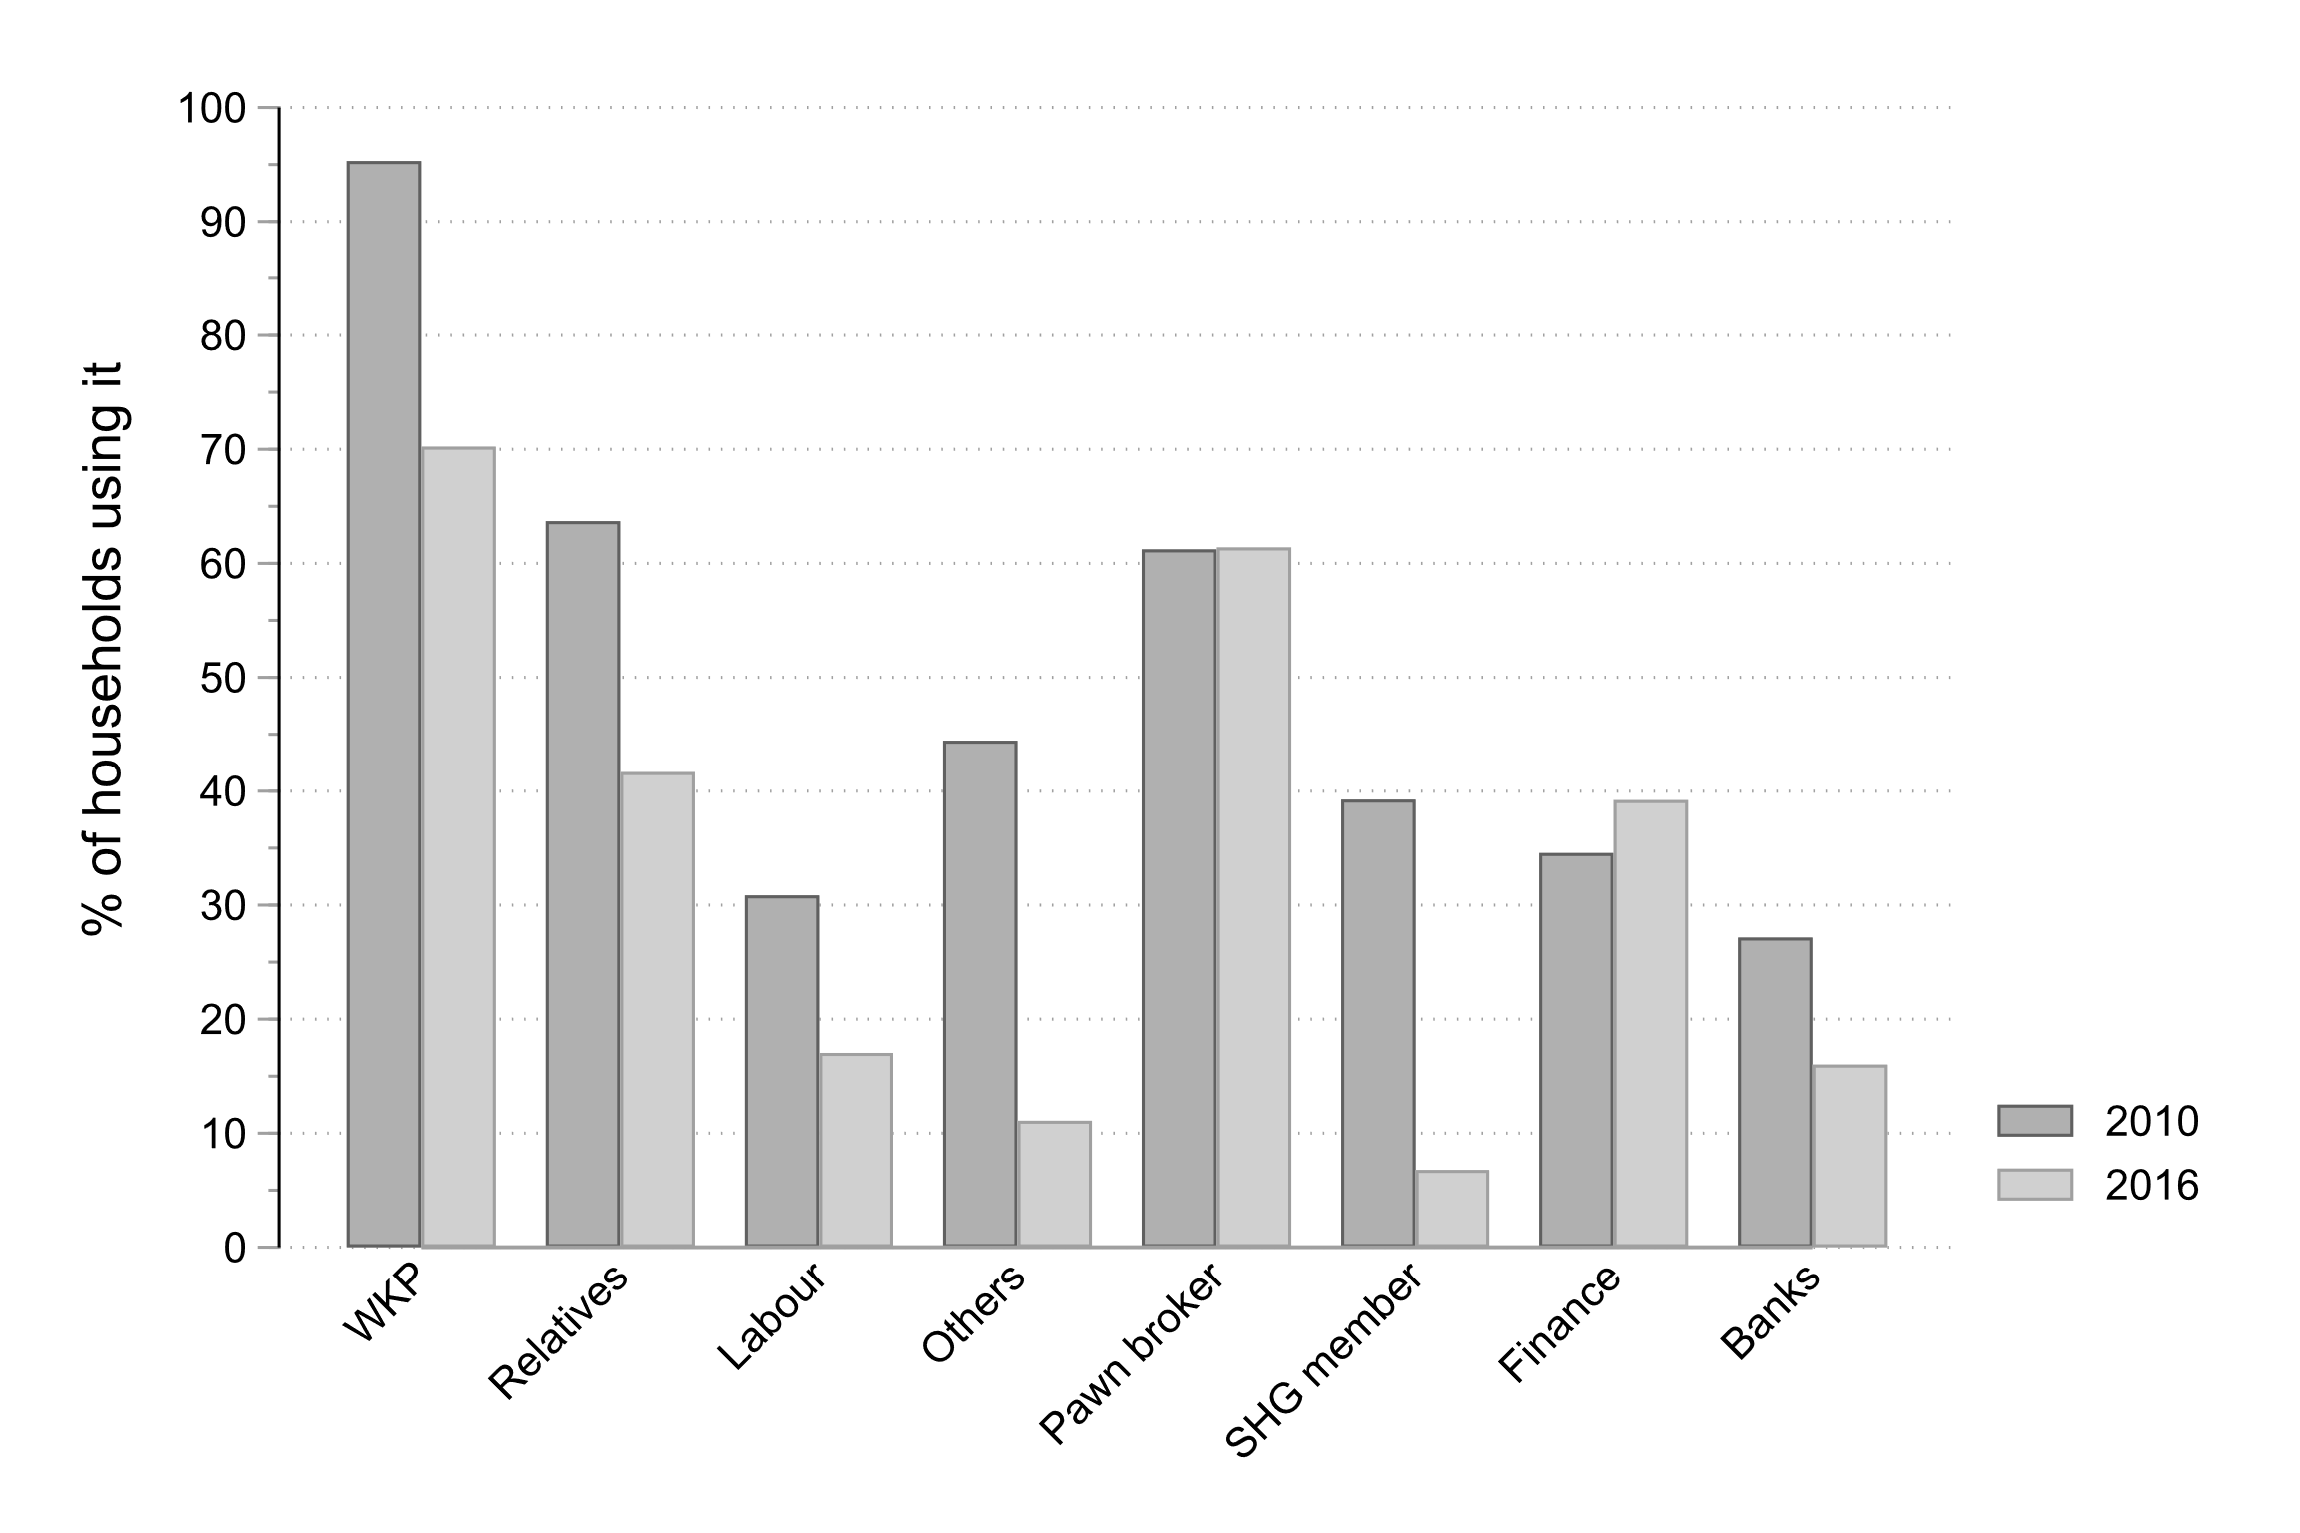

Figure 3: Source of borrowing (percent of users) -- **Source**: RUME (2010) and NEEMSIS-1 (2016-17); author’s calculations

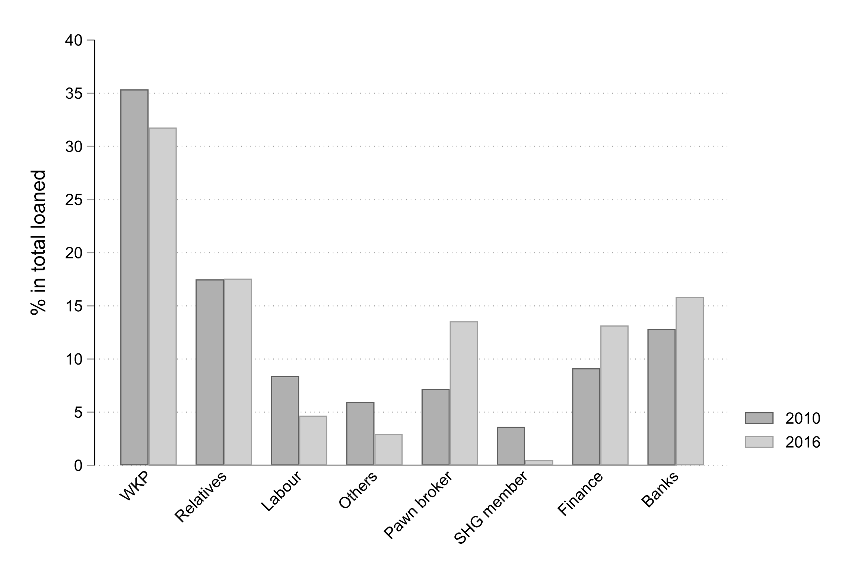

Figure 4: Source of borrowing (percent of volume) -- **Source**: RUME (2010) and NEEMSIS-1 (2016-17); author’s calculations

Table 3 Loan sources by caste and ownership -- Source: NEEMSIS-1 (2016-17); author's calculations.

|  |  |  |  |  |  |  |  |
| --- | --- | --- | --- | --- | --- | --- | --- |
|  | Total |  | Dalits | Non dalits |  | Landowner | Landless |
| Number of household | n=487 |  | n=232 | n=255 |  | n=153 | n=334 |
| Informal |  |  |  |  |  |  |  |
| *WKP* | 70.2 |  | 70.3 | 70.2 |  | 68.0 | 71.3 |
| *Relatives* | 41.7 |  | 41.8 | 41.6 |  | 47.1 | 39.2 |
| *Labour* | 17.0 |  | 21.1 | 13.3 |  | 3.9 | 23.0 |
| *Others* | 11.1 |  | 11.2 | 11.0 |  | 11.8 | 10.8 |
| Semi formal |  |  |  |  |  |  |  |
| *Pawn broker* | 61.4 |  | 58.6 | 63.9 |  | 64.7 | 59.9 |
| *SHG member* | 6.8 |  | 6.9 | 6.7 |  | 5.9 | 7.2 |
| Formal |  |  |  |  |  |  |  |
| *Finance* | 39.2 |  | 44.4 | 34.5 |  | 40.5 | 38.6 |
| *Banks* | 16.0 |  | 9.0 | 22.3 |  | 28.1 | 10.5 |
| Note: In % of households | | | | | | | |

During the survey period, finance and pawnbroking have grown in importance, both in terms of users and in terms of volume. This increase was at the expense of other sources, notably Self-Help-Groups (SHGs)[7] and debt-labour arrangements. However, WKP and relatives remain the predominant form of borrowing.

As observed elsewhere[8], informal sources persist, for several reasons. They are very flexible, which is crucial given the irregularity of income. For 84 percent of informal loans, the terms are not fixed in advance and borrowers repay when they can. Contrary to what is often claimed in the literature or media, their cost is not, on average, higher than formal sources in the region studied here (Reboul et al. 2019). Almost none of them require collateral (80 percent require only personal informal agreement). Subjective creditworthiness, reputation and trust (the three terms are equivalent in Tamil - *nampikkai)* are the key factors in lenders’ selection.

The transformation of sources of borrowing is both shaped by and constitutive of deeper social transformations, including regarding the use and building of trust. Historically, access to credit, for the landless and small landowners, was mainly based on their labour power, used as collateral and legitimized by caste hierarchies and the possible use of violence. Non-agricultural employment and migration have opened up new opportunities. In the village itself, new providers are present. In addition to microcredit organisations, many WKPs actually act as informal intermediaries for urban financial lenders. Another form of caste segmentation is worth noting, a legacy of a persistent Hindu theology of debt (Kāne 2012). As the villagers often say, “you don’t borrow from anyone lower than you”. Interestingly, however, the Dalits are borrowing more and more from other Dalits (Figure 5 and 6) (and this caste retreat is also observed in other castes)[9]. In 2010, and among loans for which the caste of the lender is known (most informal loans), 54% of Dalit borrowers borrowed from other Dalits and 26% borrowed from middle caste. In 2016-17, these shares are 70% and 21% respectively.

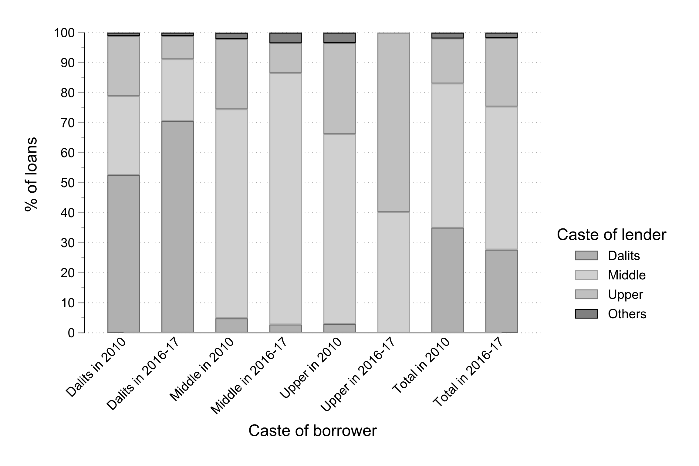

Figure 5: Debt and caste, who borrows from whom (percent of loans)? -- **Source**: RUME (2010) and NEEMSIS-1 (2016-17); author’s calculations

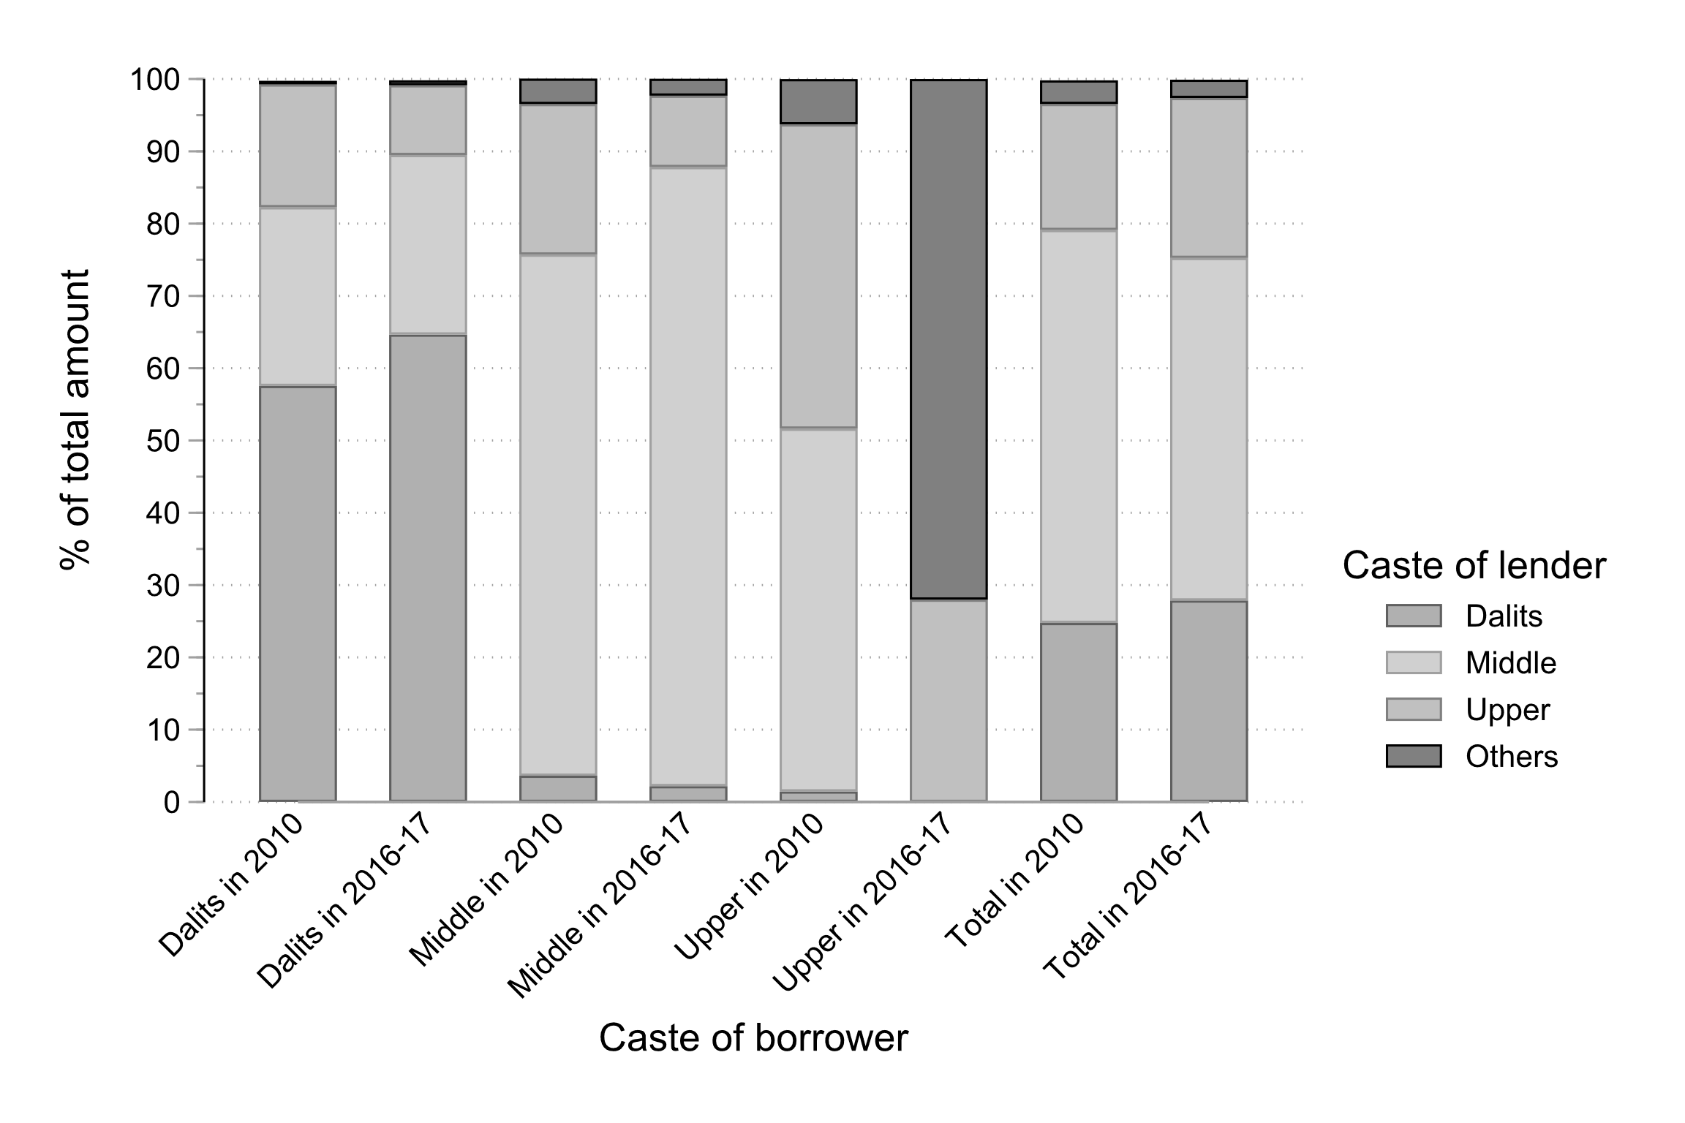

Figure 6: Debt and caste, who borrows from whom (percent of volume)? -- **Source**: RUME (2010) and NEEMSIS-1 (2016-17); author’s calculations

Trust does not mean blind faith on others, but the “the negotiation of risk occasioned by the freedom of others” (Hart 2000, p. 88). Broadly speaking, trust depends on the personal and social characteristics of the contracting parties and their respective appreciation, on a process and memory of repeated interactions (Hilger and Nordman 2020). Trust also depends on social institutions, broadly defined as the set of rules, norms and conventions that regulate the behaviour of others (Platteau 1994). The assessment of incentives and enforcement mechanisms is crucial, and depends on sanctions, the risk of loss of reputation or the risk of loss of reciprocity in case of interdependence.

For loans among relatives and microcredit loans, which remain based on the principle of group lending, interdependence nurtures trust. This does not, of course, exclude tensions and conflicts, whether within kinship or microcredit groups (Kar 2018). These are omnipresent. But the interdependence is such that relatives and group members remain bound by ties of mutual debt and cannot afford to fail.

For loans contracted from WKP, several factors come into play. Even if no collateral is required, the lender takes into account in his or her own assessment material assets - which borrowers can sell if they have difficulty repaying - and their ability to work. Migrants clearly have an advantage and labour recruiters may even be asked to act as guarantors for the first loans. As with any lender, the fabric of trust is then based on credit history and repayment behaviour. Reputation is public information, available at the village level. Reputation encompasses family history, seriousness and “morality” of different family members. Bad payers are quickly identified and discriminated against by lenders, but also by employers or labour intermediaries. They may also affect children’s marriage. Reputation is therefore an essential asset in households’ portfolios, which people constantly seek to preserve and cultivate. Here too, conflicts are legion. Disappearing from the village for a while can be a way of postponing a debt. But permanent migration remains exceptional and the attachment to the village is such that payment defaults are rare.

1. Suspension of repayment

When the lockdown was announced, the villagers expressed three major concerns: the loss of jobs, of course; the omnipresent and violent police checks, which exacerbated the climate of anxiety; and the repayment of debts, especially for women. Regarding repayment pressure, women mentioned first microcredits, since microcredits are the only loans with rigid and non-negotiable repayment terms. Repayments (most often monthly) are often a headache, since cash is constantly in short supply. The most organised borrowers regularly save small amounts; the others, in the days before the due date, spend part of their time finding money here and there by soliciting neighbours, friends, husbands and other relatives. Soon after the lockdown announcement, however, the Reserve Bank of India (RBI) announced a moratorium on repayments. Initially limited to banks, microfinance companies (most of which have non-banking financial company status) had to apply to the RBI to also be eligible for the moratorium. However, not all financial companies have been complying with the moratorium. Some required electronic applications, while many women are illiterate and most have no access to the internet. Other companies gave phone calls, requesting women to repay, and our region seems to be no exception[10]. In the cases we came across, women were well-informed and refused to let this happen, as the following testimony illustrates, but this required negotiation and collective organisation.

“The staff is torturing us daily by phone and giving warning that if we fail to repay in the due date, we have to pay interest to interest. But I strongly said that we can’t repay right now. You can arrest us or do whatever you can. How many months have we paid without fail? [...] They think if they ask the payment in an intimidating tone, people will be afraid and will settle the amount. I request the [name of the financial company] that I don’t have money to repay. I gathered all the members of the group and asked about their situation because I am the head of the group. Our members were crying and said that we don’t have income to repay. So far we have been paying properly, why are they giving pressure? Then I contacted [name of the financial company] and I told them if you were pressuring us again and again, we will register a complaint against you. Then only they stopped contacting us.”

With regard to informal loans, many creditors tried to get their money back, but most of the time without success. They did not have the means to enforce repayments, and they also had to preserve their reputation. “I also borrow elsewhere, how can I shout?”, we often heard. While this suspension of repayments may have relieved household budgets, it raises the question of how it will affect trust and reputation, one of the most valuable assets that people possess.

1. Stopping unsecured debt and the loss of trust

With the lockdown, and the immense uncertainty that goes with it, unsecured debts have stopped. While money usually circulates all the time (as does food - a kilo of rice, a glass of oil, a liter of milk), this circulation has stopped, except among very close relatives or very close friends. While during the demonetization we observed an extension of networks (and people often compare the two situations) (Guérin et al. 2017; Hilger and Nordman 2020)[11], here it was the opposite reaction. People had not lost trust in others, but in the future. Many mentioned the “collapse of trust” (*nampikkai poyvittuchi*). Uncertainty about the future prevented any trust. “People close their doors” we have been told again and again:

“Usually neighbors, sister in law, god will come… now no one is coming”.

“If there is any crisis, always someone is there to support, now all doors are closed”.

“There is no food, there is no cash, I have to find a way to protect myself; even the government says, close the doors, stay inside”.

“No one is ready to give. All say ‘we don’t have enough money’. Moreover we don’t ask money from neighbors and relations. Our only believe is daily coolie work.

“Even *kaimathu* [help from hand to hand], that’s impossible. Everyone closes the door and does not want to talk to us. They fear that people won’t return the money. People plan that it may last for one year. My village is empty. No-one wants to see us.

“Nobody wants to help […] Everybody is in some sort of trauma to say they have cash. They even hide to their close relatives”.

A milk trader whom we know well, who did whatever he could at the time of demonetization to support his network of producers, told us: “don’t ask anything!”. We shall also give the example of a labour recruiter, Dalit, whom we have known for fifteen years. We have seen him gradually build up his network of workers and creditors, which he needs to provide wage advances. Over the years, he has built up an excellent reputation by regularly protecting his workers (loans or gifts in case of illness, unforeseen events, etc.). He can count on four trusted creditors (“well-known persons”) with whom he has gradually built relationships. At the time of the lockdown, he could neither repay his creditors nor help his workers. Many of them were waiting for him in front of his house, hoping for some kind of help. He turned his phone on for only a few minutes a day. One day, he called us in desperation. He went so far as to talk about suicide. His haunting, he told us, was that they would lose their trust (*nampikkai*) in him.

We shall also mention these two co-wives, who remained hidden at home because they were indebted to several women in the neighbourhood. Their son told us that they no longer dared to go out because they would feel obliged to give what little they have. At the same time they were feeling terribly guilty.

Fear of the future and the loss of the usual networks of protection led to considerable anxiety - people were keeping asking when the lockdown will end, and more importantly, when economic activity will resume. Returning to old dependencies, from which many Dalits had tried to extricate themselves, was an alternative, as also observed in a neighbouring Tamil region (Carswell et al. 2021). This is the case of this Dalit woman:

“A woman, I know her for the last thirty years, we watch TV together, here or vice versa. I often acted as a guarantor for her; but she refused [to help]. She thinks I may not be able to return the 5 kg rice, as my family is big. Corona is closing my door. She is like my sister. Now my only choice is I am going to a Mudaliyar [upper caste]. My father in law was attached labourer there. He died but his son is still there. I will have to explain: my father in law was attached labour there, I have to build a new relation”.

Together with other women, she managed to convince a Mudaliyar (upper caste) landowner to plant cucumber and black gram and hire them. “It’s embarrassing to go begging”, she said, since her family was out of this dependency, but she had no choice, “he’s the only one who feeds us”. However, reviving old forms of protection has been only possible in irrigated villages. In dry villages, workers were desperately waiting for transport to start up again. “We have to go and move, whatever the destination and the activity”, they say.

Over time, and as observed in a neighbouring Tamil region (Carswell, De Neve, and Yuvaraj 2020), we also heard about practices of reciprocity and sharing within very limited circles, whether it is ration shop rice, prepared food, a few hundred rupees, work, transportation to go to sell or buy products. Those who were helped were carefully chosen, and immediate reciprocity was the rule. Among Dalits, people realized that this was the only way out to avoid falling back into old forms of dependency that have been so decried in recent years. It remains to be seen what will be over time the respective importance of solidarity and sharing on the one hand and hierarchy and dependency on the other.

1. The emergence of new forms of secured debt: a risk of massive depletion?

We have seen above the widespread use of pawnbrokers. Because of the crucial role of gold as savings (both precautionary and long-term savings), households buy gold whenever they can. The median amount owned increased significantly over our survey period (2010/2016-17) but only for non-Dalit. For Dalits, it decreased by 20 percent (from 40g to 32g). For all castes, about two thirds of the gold was pawned at the time of the last survey.

With the lockdown, pawnbrokers were forced by regulation to close for almost two months. A few managed to operate from home. At the end of May 2020, the others had started to reopen. At the same time, old practices were re-emerging: pawnbroking within the village, between landowners’ wives (now, mainly middle castes) and those who were severely lacking in liquidity (mostly Dalit non-farm daily labourers but also few non-Dalits). Historically, this practice was widespread when the landless or smallholders depended mainly on agriculture, and access to credit was limited. The pandemic has brought back these ancient practices of intra-village and intra-caste dependency. Due to lack of income, and lack of visibility on their future income, many households had lost their creditworthiness. Conversely, potential lenders faced themselves many uncertainties and did not want to take risk. With the loss of trust, pledging assets had become the only way to secure financial transactions. Transactions had also adapted to the shortage of cash and trust. Instead of disbursing a lump sum (usually three-quarters or two-thirds of the jewel’s value), lenders distribute small sums regularly. Not only many of them could not afford more, but borrowers themselves often asked for the minimum, to avoid being approached in their turn by their close circle. Thus this lady who pledged a piece of jewellery worth INR 30,000, borrows INR 800, then comes back a few days later to borrow INR 500. Another deposited a piece of jewelry worth INR 15,000, borrows INR 500, and a week later borrows INR 1,000. It can be assumed that they then returned regularly, depending on their needs and the cash flow availability of the lender. Some people rejected these old forms of dependency and managed differently. Regardless of the options chosen, for households who did not find employment quickly, which is likely to be the case in the non-farm sector, one may expect a massive loss of their gold assets.

Land raises similar concerns. Almost half households (46 percent) have lost land over the period. The share of landowners fell from 54 percent to 31 percent, and each caste experienced a similar decline (see Table 1). Qualitative surveys indicate that indebtedness is often an explanatory factor. Land is rarely mortgaged, but people have no other choice than selling it when they can no longer pay their creditors. Here too, new forms of secured loans have been developed, especially for bonded labourers. Among our sample, some households were making a living thanks to seasonal migration and wage advances (Michiels et al. 2021). With the lockdown, most have returned. Not only they lost their source of livelihood but they were heavily indebted, with amounts ranging from 70,000 to INR 100,000. Employers were very unlikely to write off this debt. Whether it is the brick producers or the sugar mills, they themselves were in great trouble. What is more, among the brick kiln owners, some have started to threaten their workers by demanding title deeds, something that has never happened before: until now the only collateral was labour. Given the uncertainty about the future, labour was no longer a collateral.

Conclusion

In different regions of the world, the pandemic - and the lockdown - have exposed pre-existing fragilities: insufficient health systems, excessive concentration of production chains, devaluation of essential workers, suddenly becoming visible, etc. As our case study shows, the fragility of growth based on household debt is also exposed. With the lockdown, not only have workers lost their sources of income, albeit unevenly, but they are unable to repay their debts. In the studied region, debt has sharply risen over the past decade. While debt was already a source of financial fragility and decapitalisation for part of the population, there is concern that the lockdown could accentuate this trend. The only accessible credits during the first lockdown were secured credits, based on gold or land. Although our case study is limited to a specific region and has no claim to generalization, it is probably not an isolated situation. A qualitative study in a neighbouring region shows that unequal access to credit and pressure to repay strengthens caste, gender and class inequalities (Guérin et al. 2021). Observations from other parts of India also point to the failure of financial inclusion policies in times of pandemic and lockdown (Guérin, Joseph, and Venkatasubramanian 2021). Furthermore, the sharp increase in household debt observed in many developing countries before the pandemic was already a source of concern (World Bank 2020; UNCTAD 2019; UN 2020). It is thus likely that neither our case study nor the Indian case are exceptions.

In India, farmers’ debt and its consequences in terms of suicide has been a known and debated fact for several decades (Mohanty 2005). While rural incomes are now mostly non-farm (and this is true for India in general), the extent of indebtedness in rural areas, beyond farmers, has not yet been measured. Until now, internal migration and the regular injection of liquidity (through microcredit, but also and above all through informal urban financiers) explained the sustainability of this debt system. Migration income and new debts repay old debts. Debt is chronic and its repayment takes a large part of the income, acting in fact as a rent-seeking system for lenders. Moreover, the slightest contingency is a major source of fragility and impoverishment, when the sale of assets is the only way to repay the debt. Beyond material assets, it is also personal relationships, trust and reputation that are threatened. In a predominantly informal economy, these social assets are extremely valuable (Hart 2000; Platteau 1994).

What will be left of these assets, both material and social? Only time will tell. The violence of the first lockdown follows various measures taken by the BJP-led government of Narendra Modi done since 2014 (demonetization, Goods and Services Tax reform) which strongly suggests that the aim is to “destroy” the informal economy (Harriss-White 2020). It makes no doubt that the big players in this informal economy, organised around mafia-clans (Michelutti et al. 2018), will know how to take advantage of the crisis and have already done so. As for the others, the great mass of workers, we can fear a return to old forms of dependence. But we can also anticipate new forms of solidarity to counter this dependence that the Dalits no longer want.

References

Breman, Jan. 2007. *Labour Bondage in West India: From Past to Present*. New-Delhi: Oxford University Press.

———. 2020. “The Pandemic in India and Its Impact on Footloose Labour.” *The Indian Journal of Labour Economics*, 1–19.

Carswell, Grace, Geert De Neve, Nidi Subramanyam, and S. Yuvaraj. 2021. “Lockdown and Livelihoods in Rural South India: Rethinking Patronage at the Time of Covid-19.” In *How to Live Through a Pandemic (ASA Monographs Series)*, edited by S. Abram, H. Lambert, and J. Robinson. London: Routledge.

Carswell, Grace, Geert De Neve, and S. Yuvaraj. 2020. “Fifty Days of Lockdown in India: A View from Two Villages in Tamil Nadu.” *Economic and Political Weekly* 5 (25): 7–8.

Chancel, Lucas, and Thomas Piketty. 2019. “Indian Income Inequality, 1922-2015: From British Raj to Billionaire Raj?” *Review of Income and Wealth* 65: S33–62.

Collins, Daryl, Jonathan Morduch, Stuart Rutherford, and Orlanda Ruthven. 2009. *Portfolios of the Poor: How the World’s Poor Live on $2 a Day*. Princeton: Princeton University Press.

De Neve, Geert. 2016. “The Economies of Love: Love Marriage, Kin Support, and Aspiration in a South Indian Garment City.” *Modern Asian Studies* 50 (4): 1220–49.

Goedecke, Jann, Isabelle Guérin, Bert D’espallier, and Govindan Venkatasubramanian. 2018. “Why Do Financial Inclusion Policies Fail in Mobilizing Savings from the Poor? Lessons from Rural South India.” *Development Policy Review* 36: O201–19.

Greene, Joshua C., and Solène Morvant-Roux. 2020. “Social Reproduction, Ecological Dispossession and Dependency: Life Beside the Río Santiago in Mexico.” *Development and Change*, 51(6): 1481–1510

Gregory, Chris A. 1997. *Savage Money: The Anthropology and Politics of Commodity Exchange*. Amsterdam: Arwood Academic Publishers.

Guérin, Isabelle. 2013. “Bonded Labour, Agrarian Changes and Capitalism: Emerging Patterns in South India.” *Journal of Agrarian Change* 13 (3): 405–23.

Guérin, Isabelle, Vincent Guermond, Nithya Joseph, Nithya Natarajan, and G. Venkatasubramanian. 2021. “COVID-19 and the Unequalizing Infrastructures of Financial Inclusion in Tamil Nadu.” *Development and Change*, https://doi.org/10.1111/dech.12674.

Guérin, Isabelle, Nithya Joseph, and G. Venkatasubramanian. 2021. “How Indian Financial Infrastructure Failed during the Pandemic.” *The Wire*, June 23, 2021. https://m.thewire.in/byline/isabelle-guerin-nithya-joseph-and-g-venkatasubrama.

Guérin, Isabelle, Cécile Mouchel, Christophe Jalil Nordman. 2021. “With a Little Help From My Friends? Surviving the Lockdown Using Social Networks in Rural South India.” *South Asia Multidisciplinary Academic Journal*, forthcoming.

Guérin, Isabelle, Youna Lanos, Sébastien Michiels, Christophe Jalil Nordman, and Govindan Venkatasubramanian. 2017. “Insights on Demonetisation from Rural Tamil Nadu.” *Economic & Political Weekly* 52 (52): 45.

Guérin, Isabelle, Solène Morvant-Roux, and Magdalena Villarreal, eds. 2013. *Microfinance, Debt and over-Indebtedness: Juggling with Money*. London and New-York: Routledge.

Guérin, Isabelle, G. Venkatasubramanian, and Sébastien Michiels. 2014. “Labour in Contemporary South India.” In *Indian Capitalism in Development*, edited by Barbara Harriss-White and Judith Heyer, 118–35. London: Routledge.

Guérin, Isabelle, Govindan Venkatasubramanian, and Santosh Kumar. 2020. “Rethinking Saving: Indian Ceremonial Gifts as Relational and Reproductive Saving.” *Journal of Cultural Economy* 13 (4): 387–401.

Harriss, John. 2013. “Does ‘Landlordism’Still Matter? Reflections on Agrarian Change in I Ndia.” *Journal of Agrarian Change* 13 (3): 351–64.

Harriss, John, and J. Jeyaranjan. 2016. “Rural Tamil Nadu in the Liberalization Era: What Do We Learn from Village Studies?” In *The Changing Village in India: Insights from Longitudinal Research*, edited by Himanshu, Jha, and Rodgers. New Delhi: Oxford University Press.

Harriss-White, Barbara. 2003. *India Working: Essays on Society and Economy*. Vol. 8. Cambridge: Cambridge University Press.

———. 2020. “The Modi Sarkar’s Project for India’s Informal Economy.” *The Wire*, May 20, 2020. https://thewire.in/political-economy/the-modi-sarkars-project-for-indias-informal-economy.

Hart, Keith. 2000. “Kinship, Contract, and Trust: The Economic Organization of Migrants in an African City Slum.” *Trust: Making and Breaking Cooperative Relations*, 176–93.

Heyer, Judith. 2012. “Labour Standards and Social Policy: A South Indian Case Study.” *Global Labour Journal* 3 (1): 91–117.

Hilger, Anne, and Christophe Jalil Nordman. 2020. “The Determinants of Trust: Evidence from Rural South India.” *IZA Discussion Paper No. 13150*.

Kāne, Pāṇḍuraṅga Vāmana. 2012. *History of Dharmaśāstra (Ancient and Mediæval Religious and Civil Law)*. 1st Ed. 1941. Poona: Bhandarkar Oriental Research Institute.

Kar, Sohini. 2018. *Financializing Poverty: Labor and Risk in Indian Microfinance*. Stanford: Stanford University Press.

Michelutti, Lucia, Ashraf Hoque, Nicolas Martin, David Picherit, Paul Rollier, Arild E. Ruud, and Clarinda Still. 2018. *Mafia Raj: The Rule of Bosses in South Asia*. Stanford: Stanford University Press.

Michiels, Sébastien, Christophe Jalil Nordman, Suneha Seetahul. 2021. “Many Rivers to Cross: Social Identity, Cognition and Labour Mobility in Rural India.” *The Annals of the American Academy of Political and Social Science*, forthcoming.

Mohanty, Bibhuti B. 2005. “‘We Are like the Living Dead’: Farmer Suicides in Maharashtra, Western India.” *Journal of Peasant Studies* 32 (2): 243–76.

Nair, Tara S. 2016. “In Pursuit of an Inclusive Finance-Scape in India: Changing Course, Shifting Goals.” In *Social Development Report 2016*, edited by Kalpana Kannabiran and Asha Hans, 279–94. New Delhi: Oxford University Press.

Nordman, Christophe Jalil, Isabelle Guérin, Arnaud Natal, Sébastien Michiels, and Govindan Venkatasubramanian. 2019. “NEEMSIS Survey Report: A Full Statistical Picture of the Household and Individual Data.” Pondicherry-Paris: French Institute of Pondicherry – IFP, Institut de Recherche pour le Développement – IRD.

Nordman, Christophe Jalil, Isabelle Guérin, Govindan Venkatasubramanian, Sébastien Michiels, Youna Lanos, Santosh Kumar, Antony Raj, and Anne Hilger. 2017. “NEEMSIS Survey Manual (Technical Report). IRD, November, 38 Pages :” Pondicherry-Paris: French Institute of Pondicherry - IFP, Institut de Recherche pour le Développement – IRD.

Pandian, M. S. S. 2000. “Dalit Assertion in Tamil Nadu: An Exploratory Note.” *Journal of Indian School of Political Economy* 12 (3 & 4): 501–17.

Platteau, Jean-Philippe. 1994. “Behind the Market Stage Where Real Societies Exist ‐ Part I: The Role of Public and Private Order Institutions.” *The Journal of Development Studies* 30 (3): 533–77.

Reboul, Elena, Isabelle Guérin, Antony Raj, and G. Venkatasubramanian. 2019. “Managing Economic Volatility. A Gender Perspective.” Working Papers CEB 19-015, ULB.

Servet, Jean-Michel, and Hadrien Saiag. 2013. “Household Over-Indebtedness in Northern and Southern Countries: A Macro-Perspective.” In *Microfinance, Debt and Over-Indebtedness*, edited by Isabelle Guérin, Solène Morvant-Roux, and Magdalena Villarreal, 44–65. London and New-York: Routledge.

Shah, Alpa, Jens Lerche, Richard Axelby, Delel Benbabaali, Brendan Donegan, Jayaseelan Raj, and Vikramaditya Thakur. 2018. *Ground Down by Growth. Tribe, Caste, Class, and Inequality in Twenty-First Century India*. London: Pluto Press.

Srivastava, Ravi. 2020. “Covid-19 and Circular Migration in India.” *Review of Agrarian Studies* 10 (1). http://ras.org.in/covid_19_and_circular_migration_in_india.

Subramanian, Arvind. 2019. “India’s GDP Mis-Estimation: Likelihood, Magnitudes, Mechanisms, and Implications.” Center for International Development. Harvard University CID Faculty Working Paper No. 354.

UN. 2020. “Private Debt and Human Rights.” Report of the Independent Expert on the effects of foreign debt and other related international financial obligations of States on the full enjoyment of human rights, particularly economic, social and cultural rights. Geneva: UN.

UNCTAD. 2019. “Trade and Development Report 2019. Financing A Global Green New Deal.” Geneva: United Nations.

World Bank. 2020. “Global Waves of Debt. Causes and Consequences.” Washington DC: International Bank for Reconstruction and Development / The World Bank.

1. This research has been made thanks to the financial support of the Agence Universitaire de la Francophonie (AUF), through the COVINDIA project, which combines food distribution to villagers and a survey of villagers' survival tactics and strategies. For more details, see https://odriis.hypotheses.org/projects#covindia. We sincerely thank Barbara Harriss-White, Judith Heyer, Solène Morvant-Roux and Jean-Michel Servet for their very helpful comments on an earlier draft.
2. For further details, see the survey dedicated website <https://neemsis.hypotheses.org/> and the NEEMSIS manual and statistical report (Nordman et al. 2017; 2019). In the NEEMSIS (2016-17), individuals from the first wave of the survey who are now living elsewhere were also tracked and interviewed. Their place of residence includes 9 villages from Kancheepuram and Tiruppur districts.
3. For more details, see https://odriis.hypotheses.org/
4. There are also a few Padayachis, Gramanis, Navithars, Nattars, Kulalars and Asarai, who have a similar position in the caste hierarchy.
5. For converging findings on other parts of Tamil Nadu, see (Heyer 2012; Harriss and Jeyaranjan 2016).
6. Arvind Subramanian, former Chief Economic Advisor to the Government of India (2014–2018), considers that between 2011 and 2017, the annual GDP growth would be 4.5 percent and not 7 percent (Subramanian 2019).
7. SHGs were India’s first microcredit model. SHGs are groups of 15 to 20 people, mainly women, who first circulate money among themselves and are then eligible for external credit, provided by an NGO, a micro-credit institution or a bank. In the region studied here, with the advent of for-profit micro-credit companies, SHGs have all but disappeared. However, joint liability groups are still the main collateral.
8. See for instance (Collins et al. 2009; Guérin, Morvant-Roux, and Villarreal 2013).
9. We shall note the existence of internal Dalit hierarchies, the term being a political category that in fact includes many *jatis* (castes).
10. <https://www.thehindu.com/news/cities/Madurai/collector-warns-against-violation-of-rbi-norms-on-loan-moratorium/article31664789.ece/amp/>; <https://www.thehindu.com/news/national/tamil-nadu/private-finance-firms-putting-pressure-on-self-help-group-women-says-rajapalayam-mla/article31663098.ece>
11. Our NEEMSIS survey had to be discontinued due to demonetization, which allowed us to measure its effects.